Following D. Sebilleau, J. Phys. Condens. Matter **7**, 6211 (1995).

Let us consider an outgoing spherical wave of angular momentum $L=(l,m)$ centered on an atom *i* situated at ***r****i* with respect to the origin, and incoming on an atom *j* located at ***r****j*. From partial wave theory [1], we know that such a wave can be represented by the wave function (to within a constant amplitude factor)

|  |  |
| --- | --- |
|  |  |

With $h_{l}^{\left(1\right)}\left(kr\right)$ being a spherical Hankel function of the first kind [2], $Y_{L}(\hat{r})$ a spherical harmonic and $\hat{r}$ the unit vector in the direction of ***r***.

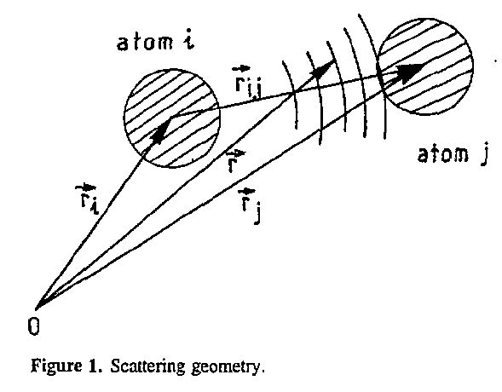

Such a wave cannot be scattered directly by atom *j* but must first be re-expanded as a linear combination of spherical waves centered on the scatterer:

|  |  |
| --- | --- |
|  |  |

Where $r_{ij}=r_{j}-r_{i}$ as defined in Figure 1.

The coefficients of the linear combination are the matrix elements of the free electron propagator $G_{0}^{+}(k)$ taken between state $\left\langle \left.L^{'},k\right|\right.$ centered at ***r****j* and state $\left.\left|L,k\right.\right\rangle$ centered at ***r****i* .

Relations such as equation (2) are called addition theorems and have been known for some time now. Here,

|  |  |
| --- | --- |
|  |  |

(NOTE TO SELF – this can be used to check the RA implementation) With

|  |  |
| --- | --- |
|  |  |

is a Gaunt coefficient and is usually expressed in terms of Wigner’s 3j symbols for numerical calculations.

Introducing the Hankel polynomial $c_{l}(kr)$ [2] by

|  |  |
| --- | --- |
| $$i^{l}h_{l}^{\left(1\right)}\left(kr\right)=\frac{e^{ikr}}{ikr}c_{l}(kr)$$ |  |

i.e., the correction factor to the asymptotic form of the spherical Hankel function, we can write $G_{L^{'}L}(r_{ij})$ conveniently in terms of its reduced form ${\tilde{G}}_{L^{'}L}(r_{ij})$

|  |  |
| --- | --- |
| $$G_{L^{'}L}(r_{ij})=4π\frac{e^{ikr_{ij}}}{ikr_{ij}}{\tilde{G}}_{L^{'}L}(r_{ij})$$ |  |

We can now rotate the bond direction $r_{ij}$ onto the z-axis to take advantage of the fact that z is a quantization axis for the angular momentum. The expression of $G_{L^{'}L}(r_{ij})$ along the z direction will be therefore much simplified. Introducing the z-axis reduced free-electron propagator matrix elements in an angular momentum representation by

|  |  |
| --- | --- |
| $${\tilde{G}}_{L^{'}L}\left(r_{ij}\hat{z}\right)≡{\tilde{g}}_{l^{'}l}^{m}\left(r_{ij}\right)δ_{mm^{'}}=\sqrt{\frac{(2l^{'}+1)}{4π}\frac{(2l+1)}{4π}}{\tilde{h}}_{l^{'}l}^{m}\left(r_{ij}\right)δ_{mm^{'}}$$ |  |

And applying rotation matrices [8, Messiah], we can expand this in a magnetic quantum number series:

|  |  |
| --- | --- |
| $${\tilde{G}}_{L^{'}L}\left(r_{ij}\right)=\sum_{μ}{R_{m^{'}μ}^{l^{'}}\left(ϕ_{ij}-π,-θ_{ij},0\right)}{\tilde{g}}_{l^{'}l}^{μ}\left(r_{ij}\right)R_{μm}^{l}(0,θ_{ij},π-ϕ_{ij})$$ |  |

Where $(θ_{ij},ϕ_{ij})$ are the spherical polar coordinates of ${\hat{r}}_{ij}$.

Writing the Gaunt coefficients in (3) in terms of Wigner’s 3j symbols leads to

|  |  |
| --- | --- |
|  |  |

It is worth noting that this quantity and the corresponding one for ${\tilde{g}}_{l^{'}l}^{μ}\left(r_{ij}\right)$ do not depend on the sign of **. From now on we will consequently write them as ${\tilde{h}}_{l^{'}l}^{\left|μ\right|}\left(r_{ij}\right)$ and ${\tilde{g}}_{l^{'}l}^{\left|μ\right|}\left(r_{ij}\right)$. Moreover, these two quantities are symmetrical with respect to interchange of l and lprime:

|  |  |
| --- | --- |
| , |  |

These two properties are fundamental as they allow us to reduce the number of values to be computed. Furthermore, the set of values of m can most of the time be limited to the first few without significant loss of accuracy. The reason for this was argued by Barton and Shirley [5] and most recently by Rehr and Albers [9]. We refer the reader to these references for a comprehensive discussion of the matter.

## The Rehr and Albers approach

One elegant way to find a fast procedure to compute the ${\tilde{h}}_{l^{'}l}^{\left|μ\right|}\left(r_{ij}\right)$ is to use the Rehr and Albers separable representation of the matrix elements of the free-electron propagator. Following their main result, we write

|  |  |
| --- | --- |
| $${\tilde{G}}_{L^{'}L}\left(r_{ij}\right)=\sum_{μ=-λ}^{λ}{\sum_{ν=0}^{η}{{\tilde{A}}_{μν}^{L^{'}}\left(z_{ij}\right)A_{μν}^{L}\left(z_{ij}\right)}}$$ |  |

Where the contributions from the L incoming partial waves and from the various Lprime outgoing partial waves have been separated. The indices $λ=min⁡(l,l^{'})$ and $η=min⁡(l^{'},l-\left|μ\right|)$ are my introductions and $z_{ij}=1/ikr_{ij}$. The other quantities are given by

|  |  |
| --- | --- |
|  |  |
|  |  |

## Wigner 3j symbols and Gaunt coefficients

|  |  |
| --- | --- |
|  |  |

|  |  |
| --- | --- |
|  |  |

Where the Wigner 3j symbols are defined as

|  |  |
| --- | --- |
|  |  |

There are several schemes for computing these symbols in the literature, reference Sebilleau. The method he recommends is as follows.

|  |  |
| --- | --- |
| $$j_{3}A\left(j_{3}+1\right)\left(\begin{matrix}j_{1} & j_{2} & j_{3}+1 \\ m_{1} & m_{2} & m_{3}\end{matrix}\right)+B\left(j_{3}\right)\left(\begin{matrix}j_{1} & j_{2} & j_{3} \\ m_{1} & m_{2} & m_{3}\end{matrix}\right)+\left(j_{3}+1\right)A\left(j_{3}\right)\left(\begin{matrix}j_{1} & j_{2} & j_{3}-1 \\ m_{1} & m_{2} & m_{3}\end{matrix}\right)=0$$ |  |

The computation of the coefficient B can be further simplified by noting that it admits a simple recurrence relation:

|  |  |
| --- | --- |
| $$B\left(j_{3}-1\right)=(2j_{3}-1)\left[\frac{B(j_{3})}{(2j_{3}+1)}-2j_{3}(m_{2}-m_{1})\right]$$ |  |

## Multiple Scattering Theory

|  |  |
| --- | --- |
|  |  |
|  |  |

|  |  |
| --- | --- |
|  |  |
|  |  |

The larger advantage of the separable representation is that it allows “precomputation” of matrices summing over L and converts those sums to matrix multiplications.